2025 SPECIFIC RULES
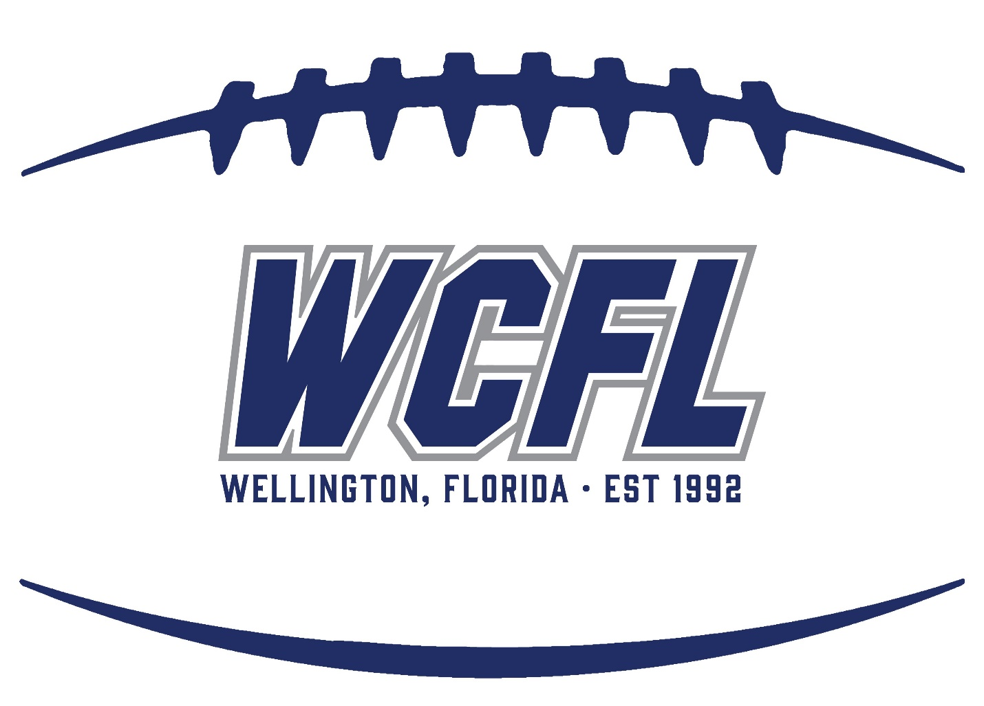
(Updated 8/25/2025)

ULTIMATE
- PLAY CLOCK— After ready for play whistle, you have 45 seconds to get a play off. You will be warned with 15 left.
- MUST PLAY RULE– All Players must play a minimum of 5 plays per half (special teams count). Violation will result in possible forfeiture of the game and game suspension for the head coach.
- KICKING GAME Ball is placed on the 40 yard line.
- PUNTS/PLACE KICKS - No live punts. If punt is declared by the Coach on the field, he simply alerts the Official that you are punting and the ball is moved 25 yards down the field and the opposing teams commences offense from there. If the punt originates from inside the opponents 40 yard line, the punt will be measured and placed half the distance to the goal. No live rushes on kicks for Extra Points/FG’s. With place kicking, the holder for extra points and field goals must setup at least 7 yards from the line of scrimmage. Field Goals/Extra Points must be completed within five (5) seconds of the snap of the ball, otherwise the play is dead. Time will be counted by the Referee. Kicking an extra point counts as two points.
- GAME BALL K2
- GAME CLOCK Ultimate will use 10 minute per quarter “running clock” with the exception of the last 2 minutes of the 4th Quarter where it will be normal operation with official stoppage required by rule shall be managed by the Head Official on the Field.
- OVERTIME PLAY Each team will have possession of the ball from the 10 yard line and four downs to score. Additional downs may be granted by a penalty against the defense. During regular season, if both teams score the game will end in a tie. During playoffs, play will continue until such time as one team scores without the other team matching the score during their corresponding possession.
- SCORING TD=6 pts, PAT Kicks= 2 pt, 3 pts for FG, Run Conversion=1 pt, Pass Conversion = 1 pts
- SIDELINES The player box will be 3 yard off the sidelines. The coaches’ box is from the 25 to the 25.
- FIELDS The ball will be placed in the middle of the field.
- MOUTHPIECE/CHIN STRAPS No clear mouth pieces. Chewed mouthpieces will have to be replaced. All chin straps must have 4 snap points and all must be utilized by the player.
- FACE SHIELDS Clear only----any tint whatsoever will not be allowed.
- Eye Glass - Clear only no tint whatsoever (unless approved by a doctor).
- UNIFORMS Players are to wear only WCFL issued uniforms—including game socks, jerseys, pants, and belt. Socks are to be worn as designed and not pulled down over the shoe.
- PANTS/LEG PADS Must be WCFL issue game paints.
- TIMEOUTS In the Ultimate Division the coach on the field may call for a timeout in addition to the head coach.
- BLITZING THE CENTER In Ultimate, you are allowed to line up in the A gaps but not directly “nose up” over center. The players in the A gaps are allowed to rush straight ahead but are not allowed to pinch down and inward on the Center as he is snapping the ball. The center can receive glancing hits as the A gap rushers are moving straight forward but not in the form of a direct hit. Once the ball is snapped and an exchange or fumble of the snap has occurred then open play is permissible. Quarterback sneaks are not permitted with the protection of the a gap but the QB can “draw”. QB “draw” is defined by the QB taking one step back and both feet come together on the step back.
- Center Snaps greater than 7 yard depth – no center shall be blitz or bull rushed over the top with the offense team in shotgun/place kick or Punt snap greater than 7 yards
- ON FIELD COACHING Coaches (one per team) shall be allowed in the huddle on both offense and defense for the entire game. The Coach is allowed to assist with player placement/positioning but must go back and stand at least 10 yds. behind the offensive/defensive backfield prior to the play commencing. There are no restrictions to on-field coach coaching.
PREP
- PLAY CLOCK— At ready for play you have 45 seconds to get a play off. You will be warned with 15 left.
- MUST PLAY RULE All Players must play a minimum of 5 plays per half (special teams count). Violation will result in possible forfeiture of the game and game suspension for the head coach.
- KICKING GAME FHSAA Rules apply to all aspects of the kicking game.
- PUNTS/PLACE KICKS. Live punts with NO live rush. No live rushes on kicks for Extra Points/FG’s. With place kicking, the holder for extra points and field goals and punts must setup at least 7 yards from the line of scrimmage. Field Goals/Extra Points must be completed within five (5) seconds of the snap of the ball, otherwise the play is dead. Time will be counted by the Referee. Punters MUST remain within the framework of the line of scrimmage. The punting team may not leave the line of scrimmage until the ball is kicked. Kicking an extra point counts as two points.
- GAME BALL K2
- GAME CLOCK Prep will use a 10 minute per quarter. Normal operation with official stoppage required by rule shall be managed by the Head Official on the Field. Clock will start on the ready for play whistle after change of possession.
- OVERTIME PLAY Each team will have possession of the ball from the 10 yard line and four downs to score. Additional downs may be granted by a penalty against the defense. During regular season, if both teams score the game will end in a tie. During playoffs, play will continue until such time as one team scores without the other team matching the score during their corresponding possession.
- SCORING TD=6 pts, PAT Kicks= 2 pt, 3 pts for FG, Run Conversion=1 pt, Pass Conversion = 1 pts
- SIDELINES The player box will be 3 yard off the sidelines. The coaches’ box is from the 25 to the 25.
- MOUTHPIECE/CHIN STRAPS No clear mouth pieces. Chewed mouthpieces will have to be replaced. All chin straps must have 4 snap points and all must be utilized by the player.
- FACE SHIELDS Clear only----any tint whatsoever will not be allowed.
- Eye Glass Clear lenses only, no tint whatsoever will not be allowed. (unless approved by a doctor)
- UNIFORMS Players are to wear only WCFL issued uniforms—including game socks, jerseys, pants, and belt. Socks are to be worn as designed and not pulled down over the shoe.
- TIMEOUTS - In the Prep division, the Head Coach or player can call a timeout. 3 per half
- BLITZING THE CENTER In Prep, you are allowed to line up in the A gaps but not directly “nose up” over center. The players in the A gaps are allowed to rush straight ahead but are not allowed to pinch down and inward on the Center as he is snapping the ball. The center can receive glancing hits as the A gap rushers are moving straight forward but not in the form of a direct hit. Once the ball is snapped and an exchange or fumble of the snap has occurred then open play is permissible. Quarterback sneaks are not permitted with the protection of the A gap but the QB can “draw”
- Center Snaps greater than 7 yard depth – no center shall be blitz or bull rushed over the top with the offense team in shotgun/place kick or Punt snap greater than 7 yards
VARSITY
- PLAY CLOCK- 45 seconds from the end of the previous play.
- MUST PLAY RULE All Players must play a minimum of 5 plays per half (special teams count). Violation will result in possible forfeiture of the game and game suspension for the head coach.
- KICKING GAME FHSAA Rules apply to all aspects of the kicking game.
- GAME BALL TDJ
- GAME CLOCK Varsity will use a 10 minute per quarter. Normal operation with official stoppage required by rule shall be managed by the Head Official on the Field. Clock will start on the ready for play whistle after change of possession.
- OVERTIME PLAY During the regular season each team will have up to two possessions of the ball from the 10 yard line. Additional downs may be granted by a penalty against the defense. If the game is still tied after the two possessions by each team the score will be declared a tie. During Playoffs the teams will each get a possession, play will continue until such time as one team scores without the other team matching the score during their corresponding possession.
- SCORING TD=6 pts, PAT Kicks= 2 pt, 3 pts for FG, Run Conversion=1 pt, Pass Conversion = 1 pts
- SIDELINES The player box will be 3 yard off the sidelines. The coaches’ box is from the 25 to the 25.
- MOUTHPIECE/CHIN STRAPS No clear mouth pieces. Chewed mouthpieces will have to be replaced. All chin straps must have 4 snap points and all must be utilized by the player.
- FACE SHIELDS Clear only----any tint whatsoever will not be allowed.
- Eye Glass - Clear only no tint whatsoever (unless approved by a doctor) will not be allowed.
- UNIFORMS Players are to wear only WCFL issued uniforms—including game socks, jerseys, pants, and belt. Socks are to be worn as designed and not pulled down over the shoe.
- TIMEOUTS - In the Varsity division, the Head Coach or player can call a timeout. 3 per half

PRO
- PLAY CLOCK- 40 seconds from the from the previous play
- WEIGHTS – Unlimited weight, however, if a players weight is over 185.9 lbs they can only play offensive and defensive line and the player cannot advance the ball in any way. It will be the responsibility of the opposing coaching staff to monitor this. The opposing coach can call a timeout and let the referee know an overweight athlete advanced the ball. If it is determined this has occurred, the timeout is not charged, and the offending coach will be charged an unsportsmanlike penalty.
- MUST PLAY RULE– A minimum of 5 plays per half for all players including special teams
- KICKING GAME FHSAA Rules apply to all aspects of the kicking
- GAME BALL TDY
- GAME CLOCK 10 minute quarters. Normal operation with official stoppage required by rule shall be managed by the Head Official on the Field. Clock will start on the ready for play whistle after change of possession.
- OVERTIME PLAY During the regular season each team will have up to two possessions of the ball from the 10-yard line. Additional downs may be granted by a penalty against the defense. If the game is still tied after the two possessions by each team the score will be declared a tie. During Playoffs the teams will each get a possession, play will continue until such time as one team scores without the other team matching the score during their corresponding possession.
- SCORING TD=6 pts, PAT Kicks= 2 pt, 3 pts for FG, Run Conversion=1 pt, Pass Conversion = 1 pts
- SIDELINES The player box will be 3 yard off the sidelines. The coaches’ box is from the 25 to the 25.
- MOUTHPIECE/CHIN STRAPS No clear mouth pieces. Chewed mouthpieces will have to be replaced. All chin straps must have 4 snap points and all must be utilized by the player.
- FACE SHIELDS Clear only----any tint whatsoever will not be allowed.
- Eye Glass - Clear only no tint whatsoever (unless approved by a doctor) will not be allowed.
- UNIFORMS Players are to wear only WCFL issued uniforms—including game socks, jerseys, pants, and belt. Socks are to be worn as designed and not pulled down over the shoe.
- TIMEOUTS The Head Coach or player can call a timeout. 3 per half

The Board of Directors Reserves the Right to Look at All Rules on a Case-by-Case Basis

